9

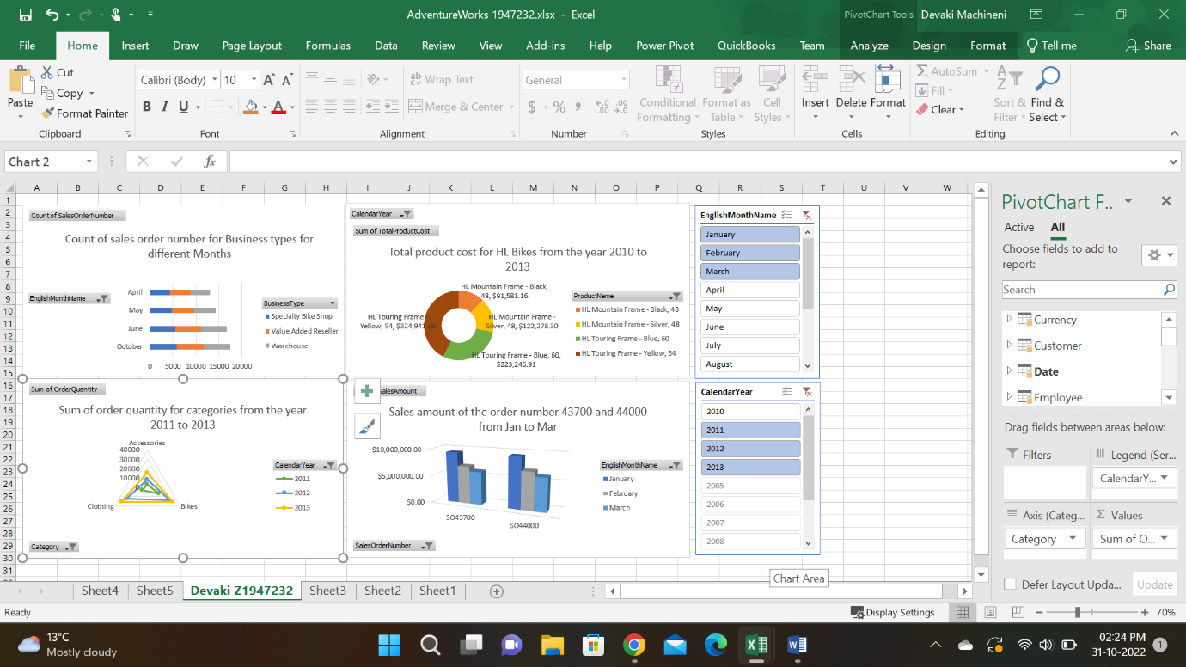

Chart-1: Count of sales order numbers for Speciality bike shop, Warehouse, and Value Added Reseller(Business Types) for April, May, June, and October :

In chart 1, I’ve created a comparison of the sales order numbers in April, May, June, and October of specialty bike shops, value-added resellers, and warehouses. To clarify the order numbers, I have used a bar chart. The X-axis represents the months and the Y-axis represents the sales order numbers.

Chart-2: Total product cost for HL bikes from the year 2010 to 2013:

In chart 2, I used a doughnut chart to clarify the difference in the product cost between the HL mountain frame and the touring frame from the year 2010 to 2013. The different colors of the chart represent a different kinds of frames.

Chart-3: Sum of the order quantity for categories from the year 2011 to 2013:

In chart 3, I have created the order quantities of the different categories of accessories, clothing, and bikes from 2011 to 2013. Here to clarify the information I have used the radar chart. The slicer displays the values of selected years. The different colors in the chart indicate the different categories.

Chart-4: Sales amount for sales order numbers 43700 and 44000 from the month of January to March:

In chart 4, I wanted to show the sales amount for sales order numbers 43700 and 44000 from the month of January and March. Here I used a column chart to clarify the order numbers. The slicer displays the names of selected months. The X-axis indicates the sales order number and Y-axis indicates the sales amount of the order numbers.